
ECONOMIC DEVELOPMENT COMMISSION
Public Notice of a Regular Meeting
Be advised that the City of Richmond Economic Development Commission will hold its regular meeting on:
October 9, 2024 - 11:30 am -1:00 pm at 211 W Cutting Blvd. Richmond, CA 94804

PARTICIPATE IN-PERSON FOR THE
OCTOBER SPECIAL MEETING

AGENDA

Diana Wear
Chair

Christina Kenney
Vice-Chair

Crashelle Jackson
James Lee
Kerby Lynch
Gloria Jean Sewell-Murphy
Don Thompson
Orrian Willis

Council Liaison:
Cesar Zepeda
~~~~~~~~

Staff:
Lizeht Zepeda
Nannette Beacham
Kyle Lam

- 11:30 am - Call to Order - (5 mins)

- Roll Call, Check in, & Group Photo - (10 mins)

- Allen Brothers staff will provide a tour of the - (60 mins)

- Old and/or New Business
    - 2024 Taste of Richmond (TOR) subcommittee October 9, 2024, Restaurant Week event at Assemble, 1414 Harbour Way S, Richmond, CA 94804 and 2:00PM free pickle ball lesson for the community, The Craneway Pavilion at 1414 Harbour Way S, Richmond, CA 94804 - (10 mins)

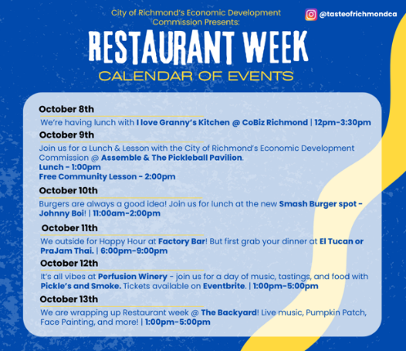

5. Public Comments/Announcements/Handouts - (5 mins)

6. Adjournment, next meeting will be a November 13, 2024.

*Note: See EDC Ordinance on reverse page.

56.060 - Officers.
The commission shall elect from among their own number a chairman and a vice-chairman who shall serve in such capacity for one year. In the case of a vacancy in the position of chairman or vice-chairman, the commission shall elect a successor who shall serve for the predecessor's term. The commission shall appoint a secretary who may be, but need not be, a member of the commission.
3.56.070 - Powers and duties.
The specific powers and duties of the commission are as follows:
- Work with state and local agencies, governing bodies, public and private organizations as appropriate to encourage economic development in the City.

- Promote the interests of commercial and industrial development in metropolitan Richmond while giving due consideration to the interests of the neighborhoods and the overall quality of life in the City.

- Review and comment on the City's program of providing economic development, business information and economic promotion services to the business community.

- Review and comment on opportunities for enhancing economic development through major public works projects, emerging growth industries, annexations, use of redevelopment, ports development, etc.

- Review and comment on programs which may enhance employment of Richmond residents.

(f) Perform other tasks related to the City's economic development as requested by the City Manager or City Council.
3.56.080 - Meetings.
The commission shall hold its first meeting within thirty days after all of its members have been appointed. At such meeting, the commission shall fix the time and place of regular meetings of the commission which shall not be less frequent than once each month. All meetings of the commission shall be open to the public.
3.56.090 - Rules and records.
The commission shall adopt rules for the transaction of the business of the commission, which rules shall, among other things, include the term of the secretary of the commission, the manner of calling and giving notice of special meetings and hearings, and the appointment and powers of standing committees. The commission shall keep records which shall be open to the public of its resolutions, transactions, motions, orders, findings, and determinations.

